CHAPTER FIVE
RESULT AND DISCUSSION
In this chapter, we will discuss the results of stochastic frontier analysis and data envelopment analysis that measures the Islamic banks efficiency in Bangladesh. The efficiency estimates have been measured using a stochastic frontier production function proposed by Battese and Coelli (1995) applied to panel data. The stochastic frontier that we have used to measure our required results is Translog stochastic frontier analysis. By using stochastic frontier analysis technical efficiency (cost and profit) on Islamic Banks of Bangladesh, Maximum Likelihood Estimates (MLE) of the parameters have been estimated. Again by using the Data Envelopment Analysis (DEA), we obtain the technical efficiency, allocative efficiency and cost and profit efficiency from the model of CRS cost DEA and CRS profit DEA. Also we use Data Envelopment Analysis to calculate Malamquist Index to measures productivity change. This chapter also devotes to examine the overall performance of Islamic banks in Bangladesh using both Stochastic Frontier and Data Envelopment Analysis.
The results of the two specification models (Cost and Profit) are presented successively.

5.1 Stochastic Frontier Analysis Results
5.1.1Maximum Likelihood Estimates for the Trans-log stochastic Frontier Cost Model
The results of maximum likelihood estimates using stochastic frontier cost model are given in Table -2. This result shows that only 2 regressors namely other earning assets and cost of labor are statistically significant. Among the outputs, other earning assets with the coefficient of β₂ (-0.315) is negative but significant for the cost model. This results implies that other earning assets has negative influence to the bank’s cost model. On the other hand the input variable, price of labor is positive but significant with the coefficient of β₅ (1.547) seems to suggest that price of labor is highly statistically significant to total operating cost. i.e. the positive influence of the labor cost to the cost model i.e. .labor cost is highly statistically significant to total operating cost. Another Inputs and outputs are insignificant but the output variable, off-balance sheet items β₃ (-0.246), the inputs, price of fixed assets β₄ (-0.515) and price of fund β₆ (-0.428) are insignificant but negative for the cost model. The square of output price of labor β₅₅ (-0.827) and the interaction term of input price and outputs, advance & price of labor β₁₅ (-0.372), other earning assets & price of labor β₂₅ (-0.398), off-balance sheet items & price of labor β₃₅ (-0.312), price of fixed assets & Price of labor β₄₅ (-0.235), Price of labor & price of fund β₅₆ (-0.322), are found negative for the cost model.

Table-2 Maximum Likelihood Estimates for the Trans-log Stochastic Frontier Cost Model
Variable | Parameter | Coefficient | Standard-error | T-ratio
Constant | 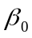 | 0.702 | 0.778 | 0.902
ADV | 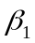 | 0.059@ | 0.297 | 0.197
OEA | 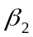 | -0.315** | 0.136 | -2.321
OBS | 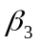 | -0.246@ | 0.312 | -0.788
PFA | 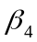 | -0.005@ | 0.421 | -0.012
POL | 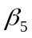 | 1.547*** | 0.917 | 1.688
POF | 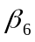 | -0.428@ | 0.276 | -1.549
(ADV)² | 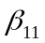 | 0.082@ | 0.737 | 0.111
ADV*OEA | 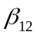 | 0.056@ | 0.888 | 0.063
ADV*OBS | 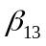 | 0.142@ | 0.89 | 0.16
ADV*PFA | 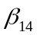 | 0.219@ | 0.891 | 0.246
ADV*POL | 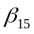 | 0.372@ | 0.901 | -0.413
ADV*POF | 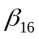 | 0-132@ | 0.889 | 0.149
(OEA)² | 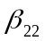 | 0.031@ | 0.733 | 0.042
OEA*OBS | 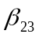 | 0.117@ | 0.889 | 0.132
OEA*PFA | 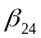 | 0.193@ | 0.891 | 0.218
OEA*POL | 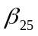 | -0.398@ | 0.902 | -0.442
OEA*POF | 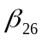 | 0.108@ | 0.888 | 0.120
(OBS)² | 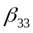 | 0.204@ | 0.744 | 0.274
OBS*PFA | 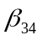 | 0.280@ | 0.898 | 0.312
OBS*POL | 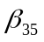 | -0.312@ | 0.894 | -0.349
OBS*POF | 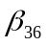 | 0.193@ | 0.891 | 0.217
(PFA)² | 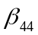 | 0.357@ | 0.748 | 0.477
PFA*POL | 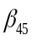 | -0.235@ | 0.892 | -0.264
PFA*POF | 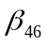 | 0.269@ | 0.892 | 0.302
(POL)² | 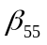 | -0.827@ | 0.808 | -1.023
POL*POF | 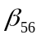 | -0.322@ | 0.902 | -0.357
(POF)² | 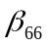 | 0.182@ | 0.741 | 0.246
Sigma-squared | б² | .1224 | 0.025 | 5.977
Gamma | γ | 0.182 | 0.089 | 2.036
*, ** . *** means significant at1%, 5% and10% @means insignificant

Table-3 Year-wise Average Cost inefficiency of Islamic Banks Using Stochastic Frontier Analysis

Year | Cost Inefficiency
2001 | 1.637
2002 | 1.773
2003 | 1.616
2004 | 1.638
2005 | 1.519
2006 | 1.439
2007 | 1.312
2008 | 1.206
2009 | 1.129
2010 | 1.122
mean | 1.548

5.1.2 Year-wise Average Cost Inefficiency of Islamic Banks Using Stochastic Frontier Analysis
The stochastic cost Inefficiency of the Islamic banks during the period 2001-2010 is presented by Table-3 and Figure-1. The average cost inefficiency of islamic banks in the frontier has shown a predictable movement over time. The average cost inefficiency of banks over the years under studies is 54.8% respectively which implies that a Islamic bank has costs that are 54.8% of its cost are wasted relative to the best practice Islamic bank producing the same output and facing the same condition. In 2001, the average cost inefficiency of islamic banks is 63.7%. Then the trend for cost inefficiency is increasing form a high of 77.3% in 2002 and then it is steadling declining from 61.6% to 12.2% untill 2010. This results conclude that, cost efficiency level has increased over the period for Islamic banks.

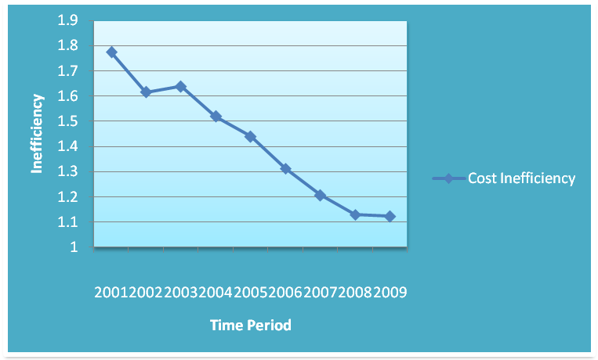

Fig-1: Average cost Inefficiency scores Over the period (2001-2010)

Table-4 Bank-wise Average Cost Inefficiency of Islamic Banks using Stochastic Frontier Analysis
Banks Name | Cost Inefficiency
IBBL | 1.136
Al-Arafah | 1.091
Shahjalal | 1.711
Social | 1.531
ICB Limited | 1.836
EXIM | 1.219
FSIB | 1.548
Mean | 1.439

5.1.3 Bank-wise Average Cost Inefficiency of Islamic Banks using Stochastic Frontier analysis
The cost inefficiency scores of Islamic banks are displayed in Table-4 and Figure-2. This results shows that the ICB limited and Shahjalal Islamic banks are recorded the most cost inefficient bank with an average inefficiency scores of 83.6% & 71.1% respectively whilst Al-Arafah & IBBL are the less cost inefficient with an average inefficiency scores of 9.1% &13.6% respectively. The average cost efficiency of Social and FSIB banks are 50% above which is also the highly cost inefficient.

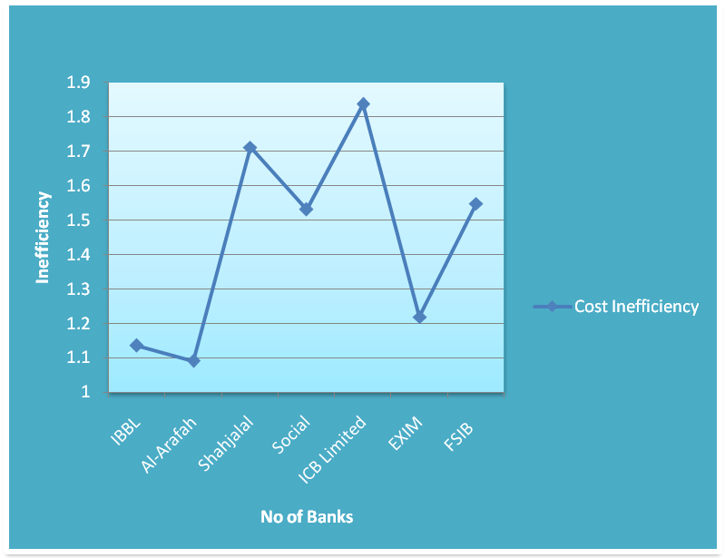
Fig-2: Average Cost Inefficiency Scores of Islamic Bank

Table-5: Generalized Likelihood-Ratio Test of Hypothesis of Stochastic Cost Frontier Model
Null Hypothesis | Log-Likelihood Function | Test Statistic λ | Critical Value | Decision
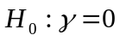 | -23.118 | 3.172 | 38.301 | Accept 
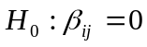 | -20.924 | 26.064 | 5.138 | Reject

5.1.4 Result of Test of Hypothesis for Stochastic Cost Frontier Model
Table-5 represents the results of various hypothesis tests conducted on the cost model. The all hypothesis tests were obtained using the generalized likelihood-ratio statistic.
- The first null hypothesis is , which specify that there is no technical efficiency effect in the Cost efficiency model. The hypothesis is accepted so we can conclude that there is a no technical efficiency effect in the model.
- The second null hypothesis is which specifies that Cobb-Douglas stochastic cost frontier model is more preferable than Translog Stochastic Cost Frontier model. From the result it is observed that the null hypothesis is rejected so Translog cost model is more preferable than the Cobb-Douglas.
Table-6: Maximum Likelihood Estimates of Trans-log Stochastic Profit Frontier Model
Variable | Parameter | Coefficient | Standard-error | T-ratio
Constant |  | 0.528 | 0.62 | 0.852
ADV |  | 0.342@ | 0.223 | 1.53
OEA |  | 0.139@ | 0.161 | 0.862
OBS |  | -0.003@ | 0.241 | -0.011
PFA |  | 0.093@ | 0.283 | 0.327
POL |  | 0.248@ | 0.483 | 0.514
POF |  | -0.421** | 0.205 | -0.021
(ADV)² |  | 0.217@ | 0.816 | 0.267
ADV*OEA |  | 0.205@ | 0.901 | 0.227
ADV*OBS |  | -0.027@ | 0.891 | -0.029
ADV*PFA |  | -0.097@ | 0.893 | -0.109
ADV*POL |  | 0.205@ | 0.956 | 0.214
ADV*POF |  | 0.156@ | 0.889 | 0.176
(OEA)² |  | 0.192@ | 0.737 | 0.261
OEA*OBS |  | -0.039@ | 0.897 | -0.044
OEA*PFA |  | -0.11@ | 0.905 | -0.122
OEA*POL |  | 0.192@ | 0.905 | 0.212
OEA*POF |  | 0.144@ | 0.909 | 0.158
(OBS)² |  | -0.271@ | 0.768 | -0.352
OBS*PFA |  | -0.342@ | 0.925 | -0.369
OBS*POL |  | -0.039@ | 0.895 | -0.044
OBS*POF |  | -0.088@ | 0.929 | -0.094
(PFA)² |  | -0.413@ | 0.796 | -0.519
PFA*POL | 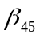 | -0.11@ | 0.889 | -0.124
PFA*POF |  | -0.159@ | 0.938 | -0.169
(POL)² |  | 0.192@ | 0.839 | 0.229
POL*POF |  | 0.144@ | 0.897 | 0.159
(POF)² |  | 0.095@ | 0.812 | 0.117
Sigma-squared | σ² | 0.136 | 0.059 | 2.283
Gamma | γ | 0.384 | 0.325 | 1.184
*means significant at1%,**means significant at 5%
***means significant at10%,@means insignificant

5.1.5 Maximum Likelihood Estimates of Trans-log Stochastic Profit Frontier Model:
Table-6 represents the results of maximum likelihood estimates of Translog profit model. The results show that, among the inputs variable, price of fund with the coefficient value of β₆ (-0.421) at 5% level is significant and negative for the profit model. This result seems to suggest that price of fund influence the profit over time and saving deposits to the profit model. Other inputs and outputs variable are found insignificant. The outputs variable off-balance sheet items with their coefficient value of β₃ (-0.003) is negative for profit model. Also the square outputs, off-balance sheet items β₃₃ (-0.271) and price of fixed assets β₄₄ (-0.413) and the mixed product between advance& off-balance sheet items β₁₃ (-0.027), advance & price of fixed assets β₁₄ (-0.974), Other earning assets & off-balance sheet items β₂₃ (-0.039), other earning assets & price of fixed assets β₂₄ (-0.11), off-balance sheet items β₃₃ (-0.271), off-balance sheet items & price of fixed assets β₃₄ (-0.342), off-balance sheet items & price of loborβ₃₅ (-0.039), off-balance sheet items & price of fund β₃₆(-0.088), price of fixed assets β₄₄ (-0.413), Price of fixed assets & price of lobor β₄₅ (-0.11), price of fixed assets & price of fund β₄₆ (-0.159) are found to be insignificant but negative for the profit model.

Table-7: Year-wise Average Profit Efficiency of Islamic Banks Using Stochastic Frontier Analysis
Year | Profit Efficiency
2001 | 0.757
2002 | 0.818
2003 | 0.825
2004 | 0.812
2005 | 0.761
2006 | 0.776
2007 | 0.791
2008 | 0.848
2009 | 0.914
2010 | 0.916
Mean | 0.822

5.1.6 Year-wise Average Profit Efficiency of Islamic Banks Using Stochastic Frontier Analysis
As seen in Table-7 and figure-3 the profit efficiency of Islamic bank shows an increasing trend for the year 2001-2010. The average profit efficiency level for Islamic bank under study is 82.2%. In 2001, the profit efficiency scores is 75.7%, then it has increasing above 80% during the periods 2002-2004 and then it has been dropped from76.1% to 79.1% in 2005 to 2007 respectively. Finally it has been moving upward until 2010. The highest profit efficiency scores of 91.6% in 2010 implies that the Islamic banking contribute the positive impacts to Bangladeshi banking industry.

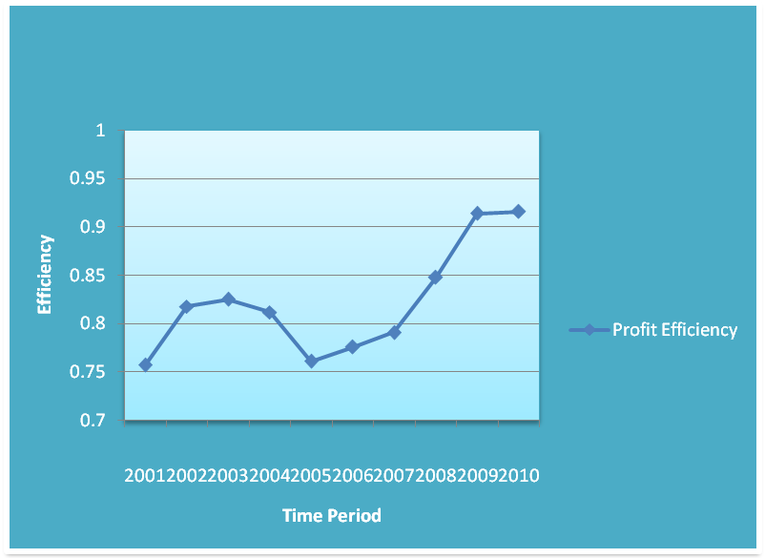
Fig-3: Average profit efficiency of Islamic banks during 2001-2010

Table-8: Bank-wise Average Profit Efficiency of Islamic Banks Using Stochastic Frontier Analysis

Bank Name | Profit Efficiency
IBBL | 0.892
Al-Arafah | 0.797
Shahjalal | 0.851
Social | 0.847
ICB Limited | 0.943
EXIM | 0.885
FSIB | 0.537
Mean | 0.745

5.1.7 Bank-wise Average Profit Efficiency of Islamic Banks using Stochastic Frontier Analysis
Table-8 and Figure-4 represented the profit efficiency scores of Islamic banks from 2001 to 2010.This result shows that the bank-wise average profit efficiency of Islamic banks is recorded 74.5% during the study period. Also we obtain the. profit efficiency scores above 70% of all Islamic banks. The most profit efficient banks are ICB limited (94.3%), IBBL(89.2%) and EXIM(88.5%) whilst FSIB bank is to be less profit efficient with efficiency score of 53.7%. Overall Islamic banks have improved their profit efficiency over the ten year periods.

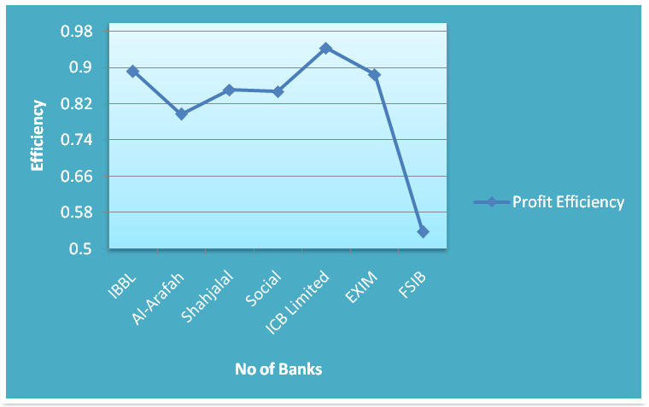
Fig-4: Bank-wise Average Profit Efficiency of Islamic Banks

Table-9: Generalized Likelihood-Ratio Test of Hypothesis of Stochastic Profit Frontier Model
Null Hypothesis | Log-Likelihood Function | Test Statistic λ | Critical Value | Decision
 | -23.118 | 12.717 | 38.301 | Accept
 | -38.937 | 24.698 | 5.138 | Reject
5.1.8 Results of Test of Hypothesis of the Stochastic Profit Frontier Model
Table-5 reports the results of various hypothesis tests conducted on the profit frontier model. The all hypothesis tests were obtained using the generalized likelihood-ratio statistic.
- The first null hypothesis is , which specify that there is no technical efficiency effect in the profit efficiency model. The hypothesis is accepted so we can conclude that there is a no technical efficiency effect in the profit model.
- The second null hypothesis is which specifies that Cobb-Douglas stochastic Profit frontier model is more preferable than Translog stochastic Profit frontier model. From the result it is observed that the null hypothesis is rejected so Translog profit model is more preferable than the Cobb-Douglas.
Table-10: Comparison: Maximum Likelihood Estimates of Trans-log Stochastic Frontier Cost and Profit Model
Variable | Parameter | MLE Estimates of
Variable | Parameter | Cost Model | Profit Model
Constant |  | 0.702 | 0.528
ADV |  | 0.059@ | 0.342@
OEA |  | -0.315** | 0.139@
OBS |  | -0.246@ | -0.003@
PFA |  | -0.005@ | 0.093@
POL |  | 1.547*** | 0.248@
POF |  | -0.428@ | -0.421**
(ADV)^2 |  | 0.082@ | 0.217@
ADV*OEA |  | 0.056@ | 0.205@
ADV*OBS |  | 0.142@ | -0.027@
ADV*PFA |  | 0.219@ | -0.097@
ADV*POL |  | 0.372@ | 0.205@
ADV*POF |  | 0-132@ | 0.156@
(OEA)^2 |  | 0.031@ | 0.192@
OEA*OBS |  | 0.117@ | -0.039@
OEA*PFA |  | 0.193@ | -0.11@
OEA*POL |  | -0.398@ | 0.192@
OEA*POF |  | 0.108@ | 0.144@
(OBS)^2 |  | 0.204@ | -0.271@
OBS*PFA |  | 0.280@ | -0.342@
OBS*POL |  | -0.312@ | -0.039@
OBS*POF |  | 0.193@ | -0.088@
(PFA)^2 |  | 0.357@ | -0.413@
PFA*POL |  | -0.235@ | -0.11@
PFA*POF |  | 0.269@ | -0.159@
(POL)^2 |  | -0.827@ | 0.192@
POL*POF |  | -0.322@ | 0.144@
(POF)^2 |  | 0.182@ | 0.095@
Sigma-squared | σ² | 0.122 | 0.136
Gamma | γ | 0.182 | 0.384
5.1.9 Comparison: Maximum Likelihood Estimates of Trans-log Stochastic Frontier Cost and Profit Model
The Trans-log profit and cost models are estimated with three outputs, three input price and their mixed products and the square of the inputs and outputs. The results of the maximum likelihood estimation are presented in Table-10 for both cost and profit models. The output variable , other earning assets is found negative but significant at 5% level and the input variable, price of labor is observed positive but significant at 10% level for the cost model. This result is not surprising considering that price of labor with the coefficient value of β₅ (1.547) because they are highly associated with cost in terms of personnel expenses such as salary, allowance. Other earning assets with the coefficient value of β₂ (-0.315) is found significant but negative for the cost model, suggesting that material, capital progress, securities and equity investment in allied and non-allied undertakings do not exert much pressure on the Islamic banks cost structure. On the other hand the input variable, price of fund with the coefficient value of β₆ (-0.413) is significant and negative for profit model at 5% level, suggest that bank can control more personnel expenses than depositor profit expenses. The profit efficiency, it seems plausible to expect a higher profit connected to the price of fund. The outputs off-balance sheet items is negative for both cost and profit models Where price of fixed assets β₅(-0.005) and price of fund β₆(-0.428) are negative for cost model only. All mixed products and the square term of input price and output variables are found insignificant for both cost and profit model. The square of input variable, price of labor β₅₅ (-0.827) is negative for cost model where the square of input variables off-balance sheet items β₃₃ (-0.271) and price of fixed assets β₄₄ (-0.413) are recorded negative for profit model. The mixed product off-balance sheet items & price of labor β₃₅ (-0.312), price of fixed assets & price of labor β₄₅ (-0.11), price of fixed assets & price of fund β₄₆ (-0.159) are observed negative for both the banks cost and profit models.

Table-11 Comparison : Year-wise Average Cost inefficiency and Profit Efficiency Scores using Stochastic Frontier Analysis
Year | Cost Efficiency | Profit efficiency
2001 | 1.637 | 0.757
2002 | 1.773 | 0.818
2003 | 1.616 | 0.825
2004 | 1.638 | 0.812
2005 | 1.519 | 0.761
2006 | 1.439 | 0.776
2007 | 1.312 | 0.791
2008 | 1.206 | 0.848
2009 | 1.129 | 0.914
2010 | 1.122 | 0.916
Mean | 1.439 | 0.822

5.1.10 Comparison: Year-wise Average Cost Inefficiency and Profit Efficiency using Stochastic Frontier Analysis
The average profit and cost efficiency scores for the sample Islamic banks are illustrated in Table-11 and Figure-5. The average profit efficiency of 82.2% and average cost inefficiency of 43.9% are evaluated. The profit efficiency of Islamic banking tended to increases whilst cost inefficiency tended to decrease over the study period. The profit efficiency of Islamic banks are recorded 75.7% to 81.2% in year 2001-2004 , then it decreased from 76.1% to 79.1% from 2005 to 2007, finally it has been moving upward until 2010. The cost inefficiency is decreasing over the period and the highest cost inefficiency level is 77.3% in 2002. Overall Islamic banks have improved their profit and cost efficiency over the study period. The trend result also provide useful information to the policy makers regarding the Islamic bank gradually contributed positive impacts to banking industry in Bangladesh .

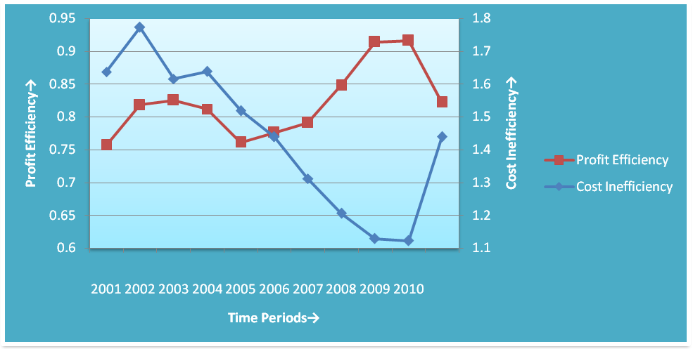
Fig-5: Year-wise Average Cost inefficiency& Profit Efficiency Score

Table-12:Comparison: Bank- wise Average Cost and Profit Efficiency of Islamic Banks using Stochastic Frontier Analysis

Bank Name | Cost Efficiency | Profit Efficiency
IBBL | 1.136 | 0.892
Al-Arafah | 1.091 | 0.797
Shahjalal | 1.711 | 0.851
Social | 1.531 | 0.847
ICB Limited | 1.836 | 0.943
EXIM | 1.219 | 0.885
FSIB | 1.548 | 0.537
Mean | 1.439 | 0.822

5.1.11 Comparison Between Bank- wise Average Cost and Profit Efficiency of Islamic Banks using Stochastic Frontier Analysis
The average efficiency scores of Islamic banks from 2001-2010 are reported in Table-12 & Figure-6.This result shows that most of the banks ranking are the same for the profit efficiencies but difference for the cost inefficiencies. The ICB limited bank is the most cost inefficient & profit efficient among the other banks with an average efficiency score of 83.6% and 94.3% respectively. The IBBL is the second cost inefficient (13.6%) and profit efficient (89.2%) banks. FSIB is the less profit efficient (53.7%) ,where Al- Arafah is the less cost inefficient (9.1%). Most of the bank has the average cost inefficiency scores above 40% which implies that Islamic banks has costs that are 60% of its cost are wasted relative to the best practice banks have producing the same output and facing the same condition. Also the result confirms that over the period of estimation, Islamic banks have become more profit efficient even though less cost efficient.
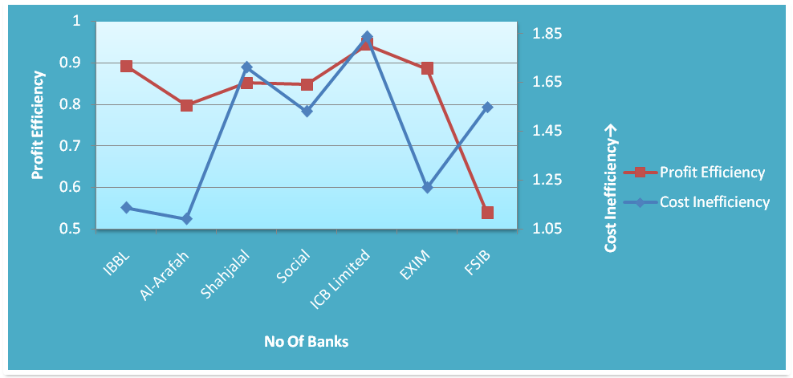
Fig-6: Average Cost & Profit Efficiency of Islamic Banks

Table-13 Cost Efficiency Estimates of Each Islamic Banks over Time

Banks | 2001 | 2002 | 2003 | 2004 | 2005 | 2006 | 2007 | 2008 | 2009 | 2010
IBBL | 1.26 | 1.481 | 1.225 | 1.154 | 1.041 | 1.043 | 1.051 | 1.032 | 1.048 | 1.031
Al-Arafah | 1.054 | 1.213 | 1.139 | 1.069 | 1.045 | 1.073 | 1.099 | 1.080 | 1.053 | 1.092
Shahjalal | 1.372 | 1.632 | 2.084 | 2.229 | 2.185 | 1.539 | 1.775 | 1.653 | 1.202 | 1.443
Social | 2.488 | 2.383 | 1.904 | 1.628 | 1.115 | 1.100 | 1.027 | 1.432 | 1.161 | 1.065
ICB | 1.291 | 1.672 | 1.997 | 2.592 | 2.782 | 2.881 | 1.968 | 1.017 | 1.111 | 1.054
EXIM | 1.569 | 1.593 | 1.319 | 1.250 | 1.209 | 1.082 | 1.033 | 1.053 | 1.045 | 1.038
FSIB | 2.425 | 2.437 | 1.645 | 1.541 | 1.259 | 1.359 | 1.228 | 1.175 | 1.283 | 1.132

5.1.11 Cost Efficiency Estimates of Each Islamic Banks over Time
The results of cost inefficiency scores using cost frontier approach of each Islamic bank during the year 2001-2010 are presented in Table-13 and Figure-7. According to the results, ICB Limited bank is the most cost inefficient bank. At the beginning of the study period the cost inefficiency scores is 29.1% in 2001 then it has been increasing until 2006 and then it has been decreasing until 2010. Based on the results, the cost inefficiency level of all Shahjalal Islami banks moving upward and downward of study period but finally at the end of the study period, it has been moving downward. The cost efficiency of social and FSIB Islami banks are increasing at the beggaining of the study period then it has been decreasing at the end of the study period. Also the results show that, IBBL, Al-Arafah and EXIM banks are more stable in terms of cost efficient than other Islamic banks.

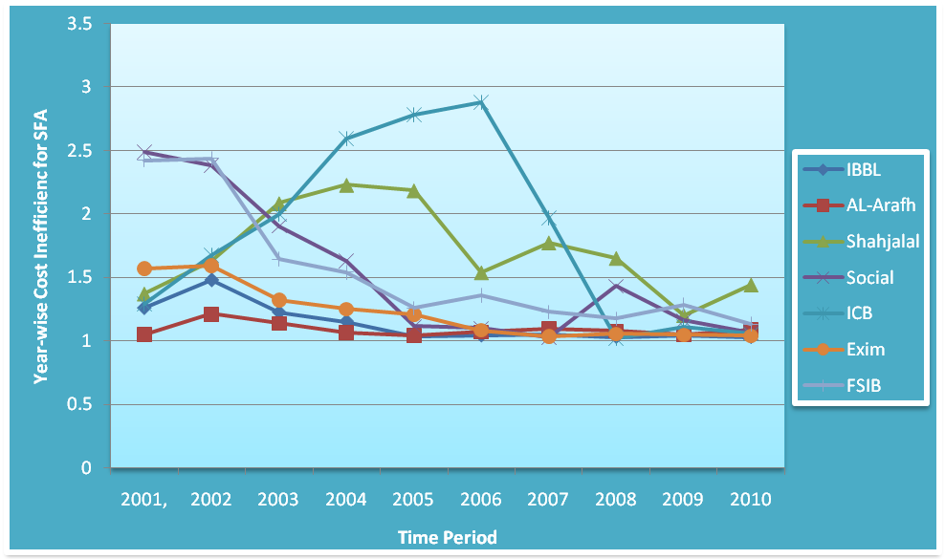
Figure-7 Cost Inefficiency Estimates of Each Islamic banks over Time

Table-14: Profit Efficiency Estimates of Each Islamic Banks Over Time

Banks | 2001 | 2002 | 2003 | 2004 | 2005 | 2006 | 2007 | 2008 | 2009 | 2010
IBBL | 0.92 | 0.94 | 0.95 | 0.96 | 0.61 | 0.67 | 0.97 | 0.96 | 0.96 | 0.97
Al-Arafah | 0.53 | 0.84 | 0.83 | 0.83 | 0.86 | 0.87 | 0.71 | 0.75 | 0.84 | 0.90
Shahjalal | 0.64 | 0.70 | 0.81 | 0.92 | 0.89 | 0.88 | 0.86 | 0.89 | 0.95 | 0.96
Social | 0.84 | 0.86 | 0.87 | 0.74 | 0.87 | 0.82 | 0.70 | 0.91 | 0.93 | 0.93
ICB | 0.96 | 0.98 | 0.97 | 0.91 | 0.92 | 0.95 | 0.95 | 0.90 | 0.95 | 0.93
EXIM | 0.83 | 0.83 | 0.89 | 0.88 | 0.92 | 0.88 | 0.86 | 0.89 | 0.92 | 0.93
FSIB | 0.54 | 0.57 | 0.45 | 0.46 | 0.26 | 0.36 | 0.48 | 0.63 | 0.84 | 0.77

5.1.12 Profit Efficiency Estimates of Each Islamic Banks Over Time
The results of profit efficiency scores of each Islamic banks during the year 2001-2010 are presented in Table-14 and Figure-8. The results show that ICB Limited bank which profit efficiency scores is always above 90% under the study period. For IBBL, the profit efficiency scores are above 90% in 2001-2004 then it has been decreasing in 60% in period 2005-2006 and then at the end of the study period it has been increasing during 2007-2010 From the period 2001 to 2004, profit efficiency of Islamic banks are most stable but in the year 2005-2006, profit efficiency scores decreased dramatically and it is around 60% and then it is increasing and at the end of the study period in 2010, IBBL is the most profit efficient with the score of 97%. At the beginning of the study period in 2001, Al-Arafah is the less profit efficient with the score of 53%. The overall result show that it has been increasing over the period. Also Social Islami banks is moving upward and downward under the study period. Shahjalal, EXIM and ICB Limited banks are more stable than other Islamic banks. FSIB banks shows less profit efficient but it has been increasing under the study period.

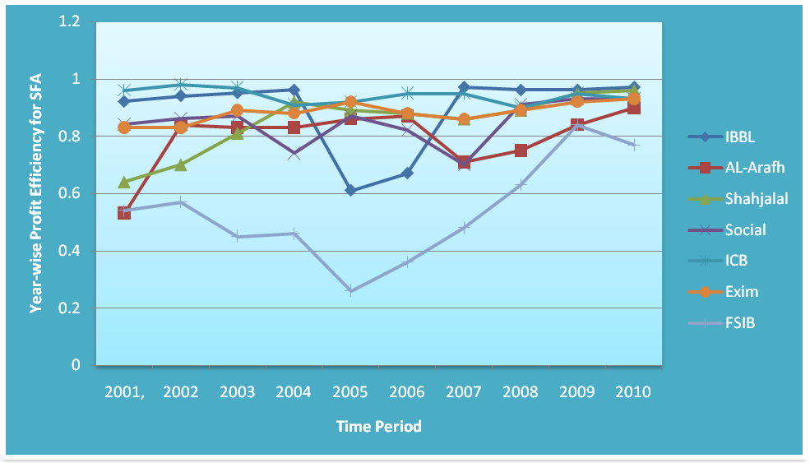
Figure-8: Profit Efficiency Estimates of Each Islamic Banks Over Time

5.2 Data Envelopment Analysis Results
Table-15 Bank-wise CRS Cost Efficiency Using Data Envelopment Analysis
Name of Banks | Cost DEA Model
Name of Banks | TE | AE | CE
IBBL | 0.143 | 0.093 | 0.013
Al-Arafah | 0.286 | 0.506 | 0.144
Shahjalal | 0.763 | 0.982 | 0.749
Social | 0.571 | 0.564 | 0.322
ICB Limited | 0.714 | 0.299 | 0.214
EXIM | 0.857 | 0.292 | 0.250
FSIB | 1.000 | 1.000 | 1.000
Mean | 0.619 | 0.534 | 0.385
TE=Technical Efficiency, AE= Allocative Efficiency, CE= Cost efficiency,

5.2.1 Bank-wise CRS Cost Efficiency Using Data Envelopment Analysis
The results of technical, allocative and cost efficiencies for each bank presented in Table-13. By definition, technical efficiency and allocative efficiency are combined to provide a measure of total cost efficiency. The average technical, allocative and cost efficiencies are found to be 61.9%, 53.4% and 38.5% respectively. FSIB is the only cost efficient bank (100%), where other banks have cost inefficient. The cost efficiency scores for IBBL, Al-Arafah, Shahjalal, ICB Limited, Social and EXIM banks are 1.3%, 1.44%,7.49%,3.22%,2.14% and 2.50% respectively. The technical efficiency is greater than allocative efficiency for IBBL, Social and EXIM banks. This implies that these banks are able to choose the proper input mix given the prices but are not able to utilize all factor inputs. Therefore the cost inefficiency may be explained at least partially by under utilization of inputs. On the other hand, the Al-Arafah, Shahjalal and ICB Limited banks are recorded allocative efficiency greater than technical efficiency. The main source of cost efficiency seems to be due to technical efficiency rather than allocative efficiency.

Table-16 Bank-wise CRS Profit Efficiency Using Data Envelopment Analysis

Name of Banks | Profit DEA Model
Name of Banks | TE | AE | PE
IBBL | 0.143 | 0.144 | 0.021
Al-Arafah | 0.709 | 0.739 | 0.524
Shahjalal | 0.434 | 0.987 | 0.428
Social | 0.571 | 0.187 | 0.107
ICB Limited | 0.714 | 0.557 | 0.398
EXIM | 0.857 | 0.618 | 0.530
FSIB | 1.000 | 1.000 | 1.000
Mean | 0.633 | 0.605 | 0.43

5.2.2 Bank-wise CRS Profit Efficiency Using Data Envelopment Analysis
The results of CRS profit efficiency of Islamic banks are presented in Table-16.The average technical ,allocative and profit efficiency scores are 63.3%, 60.5% and 43% respectively. FSIB is the most profit efficient bank with the scores of 100%. The profit efficiency scores for IBBL, Al-Arafah, Shahjalal, ICB Limited, Social and EXIM banks are 2.1%, 52.4%, 42.8%, 10.7%, 39.8% and 53% respectively. For IBBL, Al-Arafah, and Shahjalal Islamic banks, the allocative efficiency is greater than Technical efficiency,. The main source of profit efficiency seems to be due to allocative efficiency rather than technical efficiency. On the other hand, the technical efficiency is greater than allocative efficiency.

Table-17 Year-wise Cost and Profit Efficiency of Islamic Banks using Data Envelopment Analysis
Year | Cost DEA Model | Profit DEA Model
2001 | 0.908 | 0.856
2002 | 0.927 | 0.855
2003 | 1.000 | 0.911
2004 | 0.985 | 0.833
2005 | 0.976 | 1.000
2006 | 0.900 | 0.991
2007 | 1.000 | 0.974
2008 | 0.911 | 0.762
2009 | 0.842 | 0.820
2010 | 0.787 | 0.801
Mean | 0.924 | 0.881

5.2.3 Year-wise Cost and Profit Efficiency of Islamic Banks using Data Envelopment Analysis
The cost and profit scores using data envelopment analysis model over the period are presented in Table-17 and Figure-9.This results show that, the Islamic banks are most technically cost efficient in 2003 and 2007 where the banks are most profit efficient in 2005 with their scores 100% . During the period 2001-2008, the cost efficiency for Islamic banks are more stable but in the year 2009-2010, it was dramatically decreased. The profit efficiency scores are moving upward and downward under the study period. In the beginning of the study period, it is increasing then it is decreasing in 2004, then it is increasing in 2005-2007 and lastly it is decreasing until. 2010.

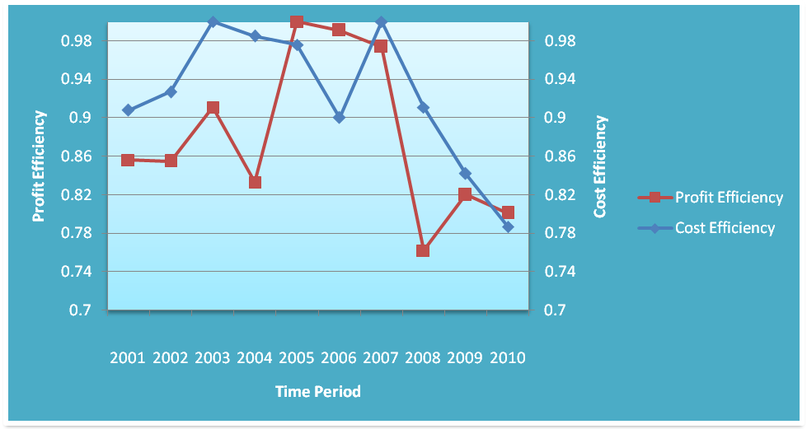
Figure-9 Year-wise Cost and Profit Efficiency of Islamic Banks Using DEA

Table-18 Comparison: Cost and Profit Efficiency of Islamic Banks using Data Envelopment Analysis
Name of Banks | Cost Efficiency | Profit Efficiency
IBBL | 0.013 | 0.021
Al-Arafah | 0.144 | 0.524
Shahjalal | 0.749 | 0.428
Social | 0.322 | 0.107
ICB Limited | 0.214 | 0.398
EXIM | 0.250 | 0.530
FSIB | 1.000 | 1.000
Mean | 0.385 | 0.43

5.2.4 Comparison: Cost and Profit Efficiency of Islamic Banks using Data Envelopment Analysis
The cost and profit efficiency of Islamic banks using Data Envelopment Analysis are presented in Table-18 and Figure-10. The bank-wise average cost and profit efficiency scores are 38.5% and 43%. This results show that, FSIB is the most cost and profit efficient bank with the efficiency score of 100% respectively where IBBL is the less cost and profit efficient with the inefficiency score of 1.3% and 2.1% respectively. This results also show that, other banks are cost inefficient.

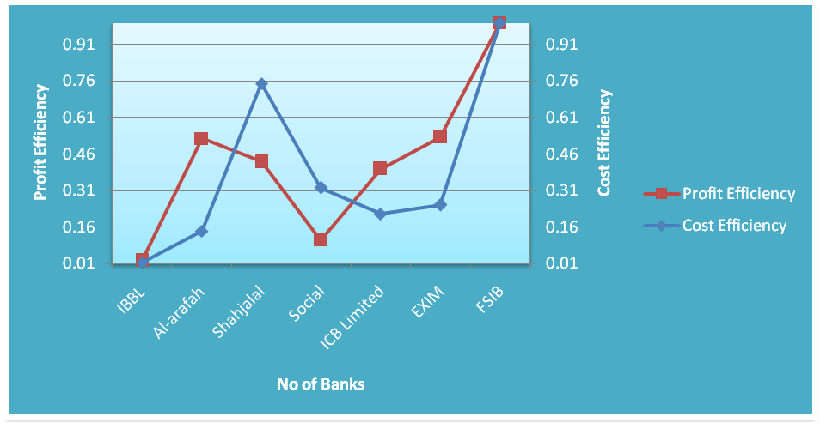
Figure-10: Cost and Profit Efficiency of Islamic Banks using DEA

Table-19 Year-wise Productivity and Efficiency Changes with Cost DEA

Period | MI | TE | TC | PTE | SE
2001-2002 | 0.986 | 1.019 | 0.968 | 1.000 | 1.019
2002-2002 | 1.114 | 1.093 | 1.020 | 1.000 | 1.093
2003-2004 | 0.789 | 0.984 | 0.802 | 1.000 | 0.984
2004-2005 | 1.098 | 0.990 | 1.109 | 1.000 | 0.990
2005-2006 | 0.906 | 1.012 | 0.895 | 1.000 | 1.012
2006-2007 | 0.946 | 1.015 | 0.932 | 1.000 | 1.015
2007-2008 | 1.117 | 0.894 | 1.248 | 1.000 | 0.894
2008-2009 | 1.105 | 0.904 | 1.222 | 1.000 | 0.904
2009-2010 | 0.831 | 0.861 | 0.965 | 1.000 | 0.861
Average | 0.980 | 0.972 | 1.009 | 1.000 | 0.972
Note: MI =Productivity Change or Malamquist Productivity Index
TC=Technological change, TE=Technical Efficiency Change
PTE=Pure Technical Efficiency Change, SE=Scale Efficiency Change

5.2.5 Year-wise Productivity and Efficiency Changes with Cost-DEA
Table-19 reports the results of Cost Malamquist Indices or productivity changes over the period 2001-2010. The average Malamquist index or productivity index is 0.980 indicate that Islamic banks have 2.0% productivity loss over the sample period. It is mentioning that productivity changes reflect the product of changes in technical and technological efficiency. According to this studies, Islamic banks have been able to achieve such productivity improvement by technologically advanced (0.9%), although they are not technically efficient. Furthermore the decomposition of total technical efficiencies into its components reveals that the scale efficiency is 2.8% where pure technical efficiency is 100%. The results suggest that the major source of technical inefficiency is scale inefficiency but not pure technical efficiency. The results further suggest that Islamic banks have achieved productivity growth of 11.4% between 2002-2003, 9.8% between 2004-2005 and 10.5% between 2008-2009 and productivity loss of 1.4% between 2001-2002, 2.11% between 2003-2004 and 9.4% between 2006-2007 and 1.29% between 2009-2010.

Table-20 Bank-wise Productivity and efficiency Changes with Cost-DEA results
Name of Banks | MI | TE | TC | PTE | SE
IBBL | 1.069 | 1.043 | 1.025 | 1.000 | 1.043
Al-Arafah | 0.963 | 0.860 | 1.121 | 1.000 | 0.860
Shahjalal | 1.012 | 0.998 | 1.013 | 1.000 | 0.998
Social | 0.936 | 1.009 | 0.927 | 1.000 | 1.009
ICB Limited | 1.066 | 1.000 | 1.066 | 1.000 | 1.000
EXIM | 0.939 | 0.992 | 0.946 | 1.000 | 0.992
FSIB | 0.892 | 0.915 | 0.975 | 1.000 | 0.915
Note: MI =Productivity Change or Malamquist Productivity Index
TC=Technological change, TE=Technical Efficiency
PTE=Pure Technical Efficiency Change, SE=Scale Efficiency Change

5.2.6 Bank-wise Productivity and Efficiency Changes with Cost-DEA
The results, of bank-wise Malamquist Index or productivity changes in the context of cost-DEA represented in Table-20. The results show that IBBL , Shahjalal and ICB Limited Islami banks increased in 6.9%, 1.2% and 6.6% productivity growth over the sample period respectively. These banks have been able to achieve such productivity improvement from becoming more technologically advanced of 2.5%, 1.3% and 6.6% respectively. These banks are more technically efficient where pure technical efficiency score is 100%. The malamquist index of Al-Arafah, Social, EXIM and FSIB banks are 3.7%, 6.4%, 6.1% and 10.8% productivity loss over the time period. Social Islami bank is technically efficient with 9%, where all other banks have technically inefficient. The major source of technical inefficiency is scale inefficiency.

Table-21 Productivity and Efficiency Change with profit-DEA

Period | MI | TE | TC | PTE | SE
2001-2002 | 1.104 | 1.016 | 1.087 | 1.000 | 1.016
2002-2002 | 0.959 | 1.094 | 0.877 | 1.000 | 1.094
2003-2004 | 0.918 | 0.892 | 1.029 | 1.000 | 0.892
2004-2005 | 1.026 | 1.288 | 0.797 | 1.000 | 1.288
2005-2006 | 1.090 | 0.990 | 1.100 | 1.000 | 0.990
2006-2007 | 0.831 | 0.952 | 0.873 | 1.000 | 0.952
2007-2008 | 1.153 | 0.765 | 1.508 | 1.000 | 0.765
2008-2009 | 1.070 | 0.719 | 1.489 | 1.000 | 0.719
2009-2010 | 0.912 | 1.084 | 0.842 | 1.000 | 1.084
Average | 1.002 | 0.964 | 1.040 | 1.000 | 0.964

5.2.7 Productivity and Efficiency Change Over Time with Profit-DEA
The Malamquist Index or productivity efficiency change of Islamic bank in the context of profit-DEA over the period are presented in Table-21.The average Malamquist index is 1.002 implies that Islamic banks have 3% productivity growth over the sample period. The average technical and technological efficiency scores are 0.964 and 1.040 respectively. The productivity improvement of Islamic banks becoming 4% technological advanced. Furthermore the decomposition of total technical efficiencies into its components reveals that the scale inefficiency is 3.6% where pure technical efficiency is 100%. The results suggest that the major source of technical inefficiency is scale inefficiency. Since the technical and scale efficiency are same because the pure technical efficiency is same for the study period. The results also suggest that Islamic banks have achieved productivity growth of 10.4% between 2001-2002, 2.6% between 2004-2005, 9% between 2005-2006, 15.3% between 2007-2008, 7% between 2008-2009 and productivity loss of 4.1% between 2002-2003, 8.2% between 2003-2004 and 16.9% between 2006-2007 and 8.8% between 2009-2010.

Table-22 Bank-wise Productivity and Efficiency Change Over Time with Profit-DEA

Names of Banks | MI | TE | TC | PTE | SE
IBBL | 1.196 | 1.101 | 1.087 | 1.000 | 1.101
Al-Arafah | 1.012 | 0.883 | 1.146 | 1.000 | 0.883
Shahjalal | 1.037 | 0.967 | 1.073 | 1.000 | 0.967
Social | 0.933 | 0.944 | 0.988 | 1.000 | 0.944
ICB Limited | 1.073 | 1.000 | 1.073 | 1.000 | 1.000
EXIM | 0.905 | 0.950 | 0.953 | 1.000 | 0.950
FSIB | 0.890 | 0.915 | 0.973 | 1.000 | 0.915

5.2.8 Bank-wise Productivity and Efficiency Change Over Time with Profit-DEA
The profit Malamquist Index and efficiency change for each bank are presented in Table-22. The results show that IBBL, Al-Arafah, Shahjalal and ICB Limited Islamic banks have increased in 19.6%, 1.2%, 3.7% and 6.6% productivity growth over the sample period respectively. These banks have been able to achieve such productivity improvement becoming more technologically advanced of 8.7%, 4.6% 7.3% and 7.3% respectively. The technical efficiency scores of IBBL and ICB Limited banks are110.1% and 100% respectively. The impact of pure technical and scale efficiencies are same on technical efficiency. The results also show that the Malamquist index of Shahjalal, EXIM and FSIB banks are 6.7%, 9.5% and 11% productivity loss over the time period. These banks are technically inefficient and also not more technologically advanced. The results of pure technical efficiency for each bank shows the same value interpret that they are full efficient.

5.3 Comparison: Stochastic Frontier Analysis and Data Envelopment Analysis

Table-23 Comparison: Cost Inefficiency and Profit Efficiency With DEA and SFA Over Time
Names of Bank | Cost Inefficiency |  | Profit Efficiency
Names of Bank | SFA | DEA | SFA | DEA
2001 | 1.637 | 0.908 | 0.757 | 0.856
2002 | 1.773 | 0.927 | 0.818 | 0.855
2003 | 1.616 | 1.000 | 0.825 | 0.911
2004 | 1.638 | 0.985 | 0.812 | 0.833
2005 | 1.519 | 0.976 | 0.761 | 1.000
2006 | 1.439 | 0.900 | 0.776 | 0.991
2007 | 1.312 | 1.000 | 0.791 | 0.974
2008 | 1.206 | 0.911 | 0.848 | 0.762
2009 | 1.129 | 0.842 | 0.914 | 0.820
2010 | 1.122 | 0.787 | 0.916 | 0.801
Mean | 1.439 | 0.924 | 0.822 | 0.881

5.3.1 Comparison: Cost Inefficiency and Profit Efficiency with DEA and SFA Over Time
The cost inefficiency and profit efficiency scores for Stochastic Frontier Analysis and Data Envelopment Analysis are presented in Table-23 and Figure-11 & 12. The average cost inefficiency scores are 43.9% and 8.2% respectively for Stochastic Frontier Analysis and Data Envelopment Analysis. These implies that the average Islamic banks could have used only has costs that are 43.9% for SFA and 8.2% of the resources actually employed over the period respectively, to produce the same level of output in these years. In 2003 and 2007, the banks show most cost efficient (100%) in Data Envelopment Analysis. Also Fgiure-11 show that the cost inefficiency of Islamic banks are slowly decreased over the time period for both frontier. Conversely the average profit efficiency scores are 82.2% and 88.1% respectively for Stochastic Frontier Analysis and Data Envelopment Analysis. Again figure-12 show that the profit efficiency of Islamic banks are increasing until 2005 then it was slowly decreased over the time period for Data Envelopment Analysis whereas in Stochastic Frontier Analysis, at the begnningthe profit efficiency are found stable at the beginning.

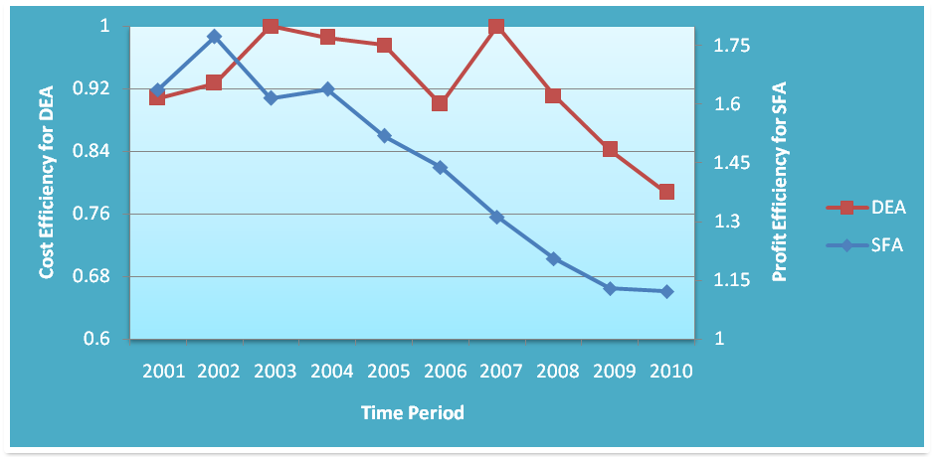
Figure-11 Cost Inefficiency with DEA and SFA Over Time Period

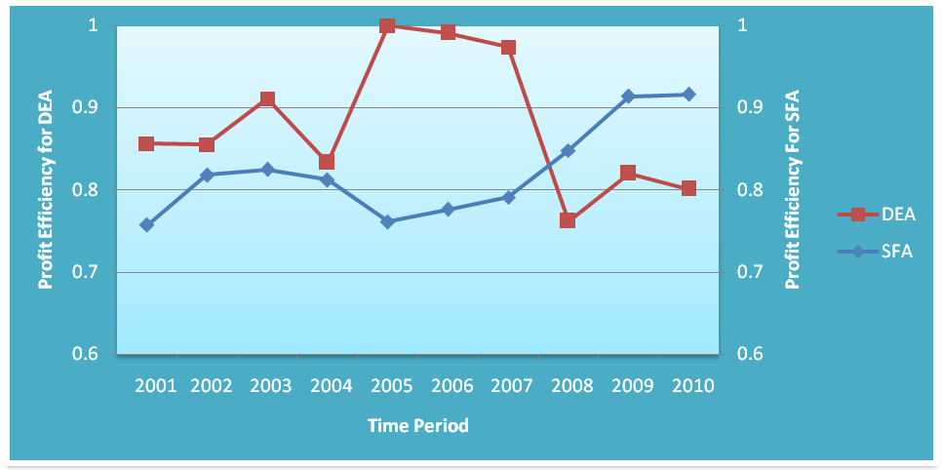
Figure-12 Profit Efficiency with DEA and SFA 0ver Time Period

Table-24 Comparison: Bank-wise Cost Inefficiency and Profit Efficiency with DEA and SFA

Names of Banks | Cost Inefficiency |  | Profit Efficiency
Names of Banks | SFA | DEA | SFA | DEA
IBBL | 1.136 | 0.013 | 0.892 | 0.021
Al-Arafah | 1.091 | 0.144 | 0.797 | 0.524
Shahjalal | 1.711 | 0.749 | 0.851 | 0.428
Social | 1.531 | 0.322 | 0.847 | 0.107
ICB Limited | 1.836 | 0.214 | 0.943 | 0.398
EXIM | 1.219 | 0.250 | 0.885 | 0.530
FSIB | 1.548 | 1.000 | 0.537 | 1.000

5.3.2 Bank-wise Cost and Profit Efficiency with DEA and SFA
The bank-wise cost and profit efficiency scores for Stochastic Frontier Analysis and Data Envelopment Analysis are presented in Table-24 and Figure-13 & 14. This results show that, FSIB is the only cost and profit efficient bank in case of DEA but it shows less cost and less profit efficient in case of SFA. Stochastic Frontier Analysis show better result than Data Envelopment Analysis in terms of cost and profit efficiencies over the study period.

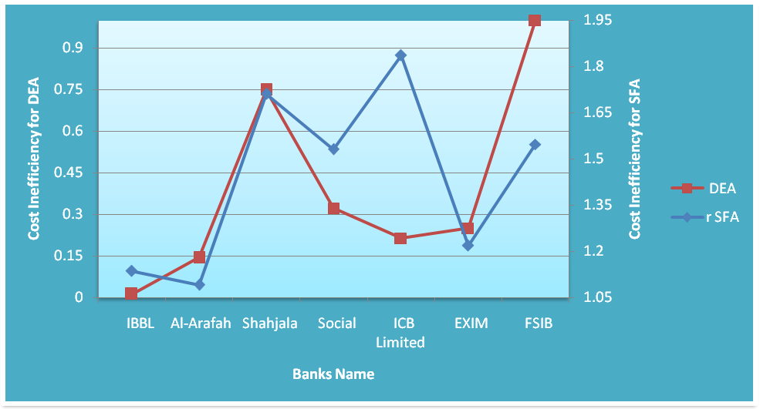
Figure-13 Bank-wise Cost Inefficiency with SFA and DEA
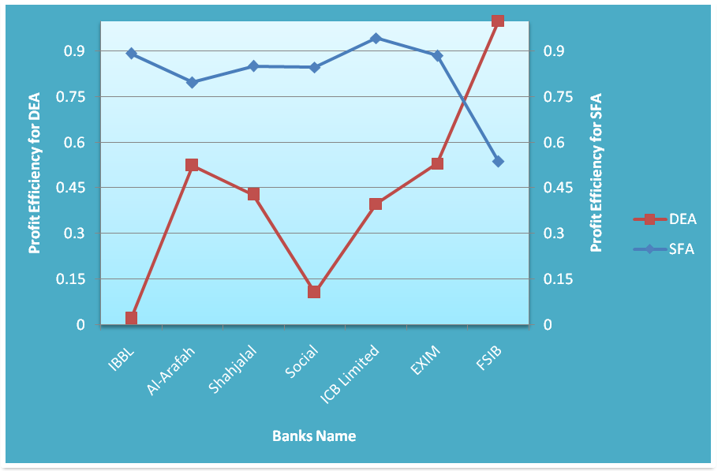 Figure-14 Bank-wise Profit Efficiency with SFA and DEA

